Course Alignment Map
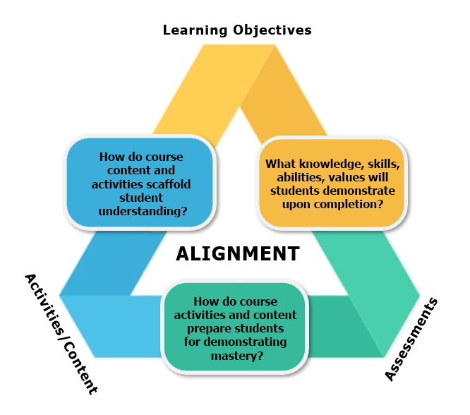
The Course Alignment Map is a visual representation of how the components of your course (assessments, activities, and learning materials) align with the stated course learning objectives. The main purpose of this document is to help course developers plan and structure their course so that it is well-aligned.
A well-aligned course means that all components of the course lead learners directly towards achieving the expected outcomes and objectives. This results in more intentional instruction, appropriate assessments, and meaningful engagement of learners.
The Course Alignment Map also serves as evidence that the alignment requirement of the DL Quality Standards has been met in the course development process.
Map Your Course
An example of a partial Course Alignment Map is given below. Use this as a guide to complete the blank Course Alignment Map on the next page for your own online course development.
Module | Learning Objectives | Learning Materials | Learning Activities | Assessment
1. Office Careers | 1.1 Identify personal strengths and areas for improvement  1.1.1 Set short- and long-term career goals  1.1.2 Create a plan of action for meeting career goals  1.2 Discuss office occupations  1.3 Explain techniques for job growth and advancement | 1.1 Online content/articles  1.2 Text Intro  1.3 Text Ch. 17 | 1.1.2 Watch video “How to make a career plan” and answer attached questions.  1.2 Browse job search sites to find dream office job, review duties, required education & experience. Share in Discussion area. | Assignment 1:  1.1 Complete personal SWOT analysis  1.1.1-1.1.2 Create career plan  1.2-1.3 Review online articles, describe 3 techniques for job growth and advancement
2. Profession-alism | 2.1 Demonstrate positive attitude characteristics  2.2 Explain the importance of punctuality and reliability  2.3 Describe self-image concepts  2.4 Distinguish between initiative and self-motivation  … | 2.1-2.4 Text Ch. 1 | 2.1-2.4 Self-quiz at end of module  2.4 Take online MindTools “Self-Motivation Quiz” | 2.1 Part of “Profession-alism & Participation” grading rubric  2.2-2.4 Professionalism Quiz (MC questions)

Course: |  | Date:
Developer: |  | ID:

Module | Learning Objectives | Learning Materials | Learning Activities | Assessment
“Chunk” the course into modules (e.g., by major topic), and list module # & name | List all PIRS objectives covered in the module, including PIRS numbering | List required materials for each objective (e.g., textbook chapters, online content, articles, videos) | List activities that allow for active learning and practice of the objectives (e.g., practice questions, online simulations, self-quizzes) | List the assessment(s) used to measure understanding of each objective (e.g., discussion, assignment, project, quiz, presentation)

